FUNDAMENTALS OF FACE READING
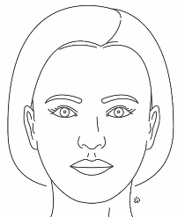
Our bodies speak without words. They are like walking billboards, communicating our thoughts, feelings and living history. The face is a map, and the eyes are a map. They both reflect who we are, states of health, genetic tendencies, personality qualities and traits and more. Face reading is fun and fascinating. It’s a valuable assessment tool easily integrated with iridology. Face Reading can expand and catapult the understanding of yourself and others on many levels. Learn how to read the face like a book.

Canadian, Jackie Latimer, has been in the holistic health field for over 38 years as a Registered Massage Therapist, Certified Colon Hydrotherapist, IIPA Iridologist and Instructor and a Face Reader and Body-Mind Analyst and Instructor. Jackie lectures nationally and internationally. She presents information in a practical manner that can be put to immediate use. Jackie is fascinated with the wisdom of the human body and its many holographic maps and messages. She enjoys the journey of self-discovery and understanding how to read the language of your body. Jackie’s teachings can help you understand yourself and others on deeper levels.

